PROJECT DEVELOPMENT PHASE

AI FAQ ASSISTANT API
Project Name: AI FAQ Assistant API
Team ID: SWTID-2026-9625
Date: 26 September 2026

1. DEVELOPMENT OVERVIEW
AI FAQ Assistant API was developed as a backend-only REST API using Node.js, Express.js, MongoDB, Mongoose, JWT, bcryptjs, and Google Gemini AI.
The development follows a modular structure with separate models, controllers, routes, middleware, and service layers. The implementation includes user authentication, role-based authorization, FAQ management, category management, tag relationships, AI-generated FAQ content, AI-assisted answers, keyword-based FAQ search, answer feedback, validation, rate limiting, and centralized error handling.

2. DEVELOPMENT ENVIRONMENT
The project was developed using:
- Node.js
- Express.js
- MongoDB
- Mongoose
- Google Gemini API
- JWT
- bcryptjs
- Postman / Thunder Client
- Visual Studio Code

3. BACKEND DEVELOPMENT
The backend was developed as a REST API using Node.js and Express.js.
The main application components are:

Models
- User
- FAQ
- Category
- Tag
- FAQTag
- AIGeneratedFAQ
- AnswerFeedback

Controllers
- Authentication
- User
- FAQ
- Category
- AI
- Feedback

Services
- Gemini Service
- Search Service

Middleware
- Authentication
- Role Authorization
- Validation
- FAQ Access / Ownership Protection
- Rate Limiting
- Error Handling
This structure separates database models, request handling, business logic, AI processing, and security processing.
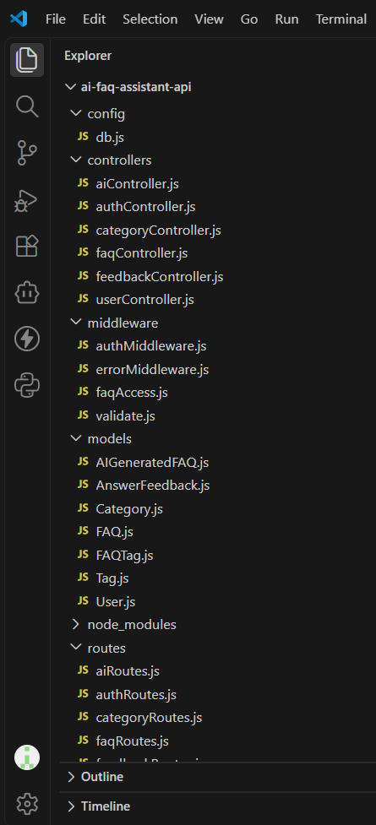
Figure 1: AI FAQ Assistant API Project File Structure

4. AUTHENTICATION DEVELOPMENT
The authentication module was implemented using JWT and bcryptjs.

Registration
POST /api/auth/register
The system accepts a user's name, email, and password. Public registration creates the user role and the password is stored in hashed form.

Login
POST /api/auth/login
The system verifies the supplied email and password and generates a JWT token after successful authentication.

Protected API Access
Authorization: Bearer <JWT_TOKEN>
The authentication middleware verifies the token before allowing access to protected resources.
The application does not expose password fields when authenticated user information is returned.
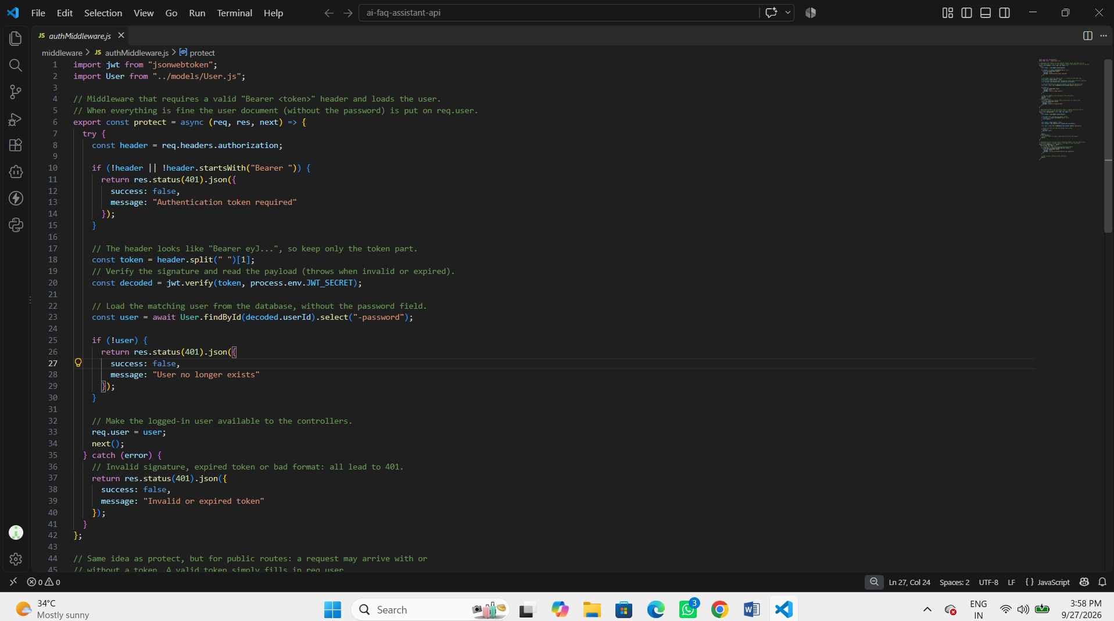
Figure 2: JWT Authentication and Authorization Middleware

5. ROLE-BASED ACCESS CONTROL DEVELOPMENT
Three application roles are implemented:
- Admin
- Content Creator
- User
Role-based middleware checks the authenticated user's role before performing restricted operations.
Administrators can manage users, categories, FAQs, and feedback. Content creators can create, update, and delete their own FAQs and use the AI FAQ generation and save functions. Regular users can access their profile, public FAQ information, search, AI-assisted answers, and feedback functions according to the implemented routes.
FAQ ownership checks prevent content creators from modifying FAQs that belong to another user.

6. FAQ MANAGEMENT DEVELOPMENT
The FAQ module was developed with create, retrieve, update, delete, ownership, visibility, and search operations.

APIs
- POST /api/faqs
- GET /api/faqs
- GET /api/faqs/:id
- GET /api/faqs/mine
- GET /api/faqs/admin/all
- PUT /api/faqs/:id
- DELETE /api/faqs/:id
- GET /api/faqs/search?q=<search-term>
The module includes:
- Question and answer
- User reference
- Category reference
- Tags
- Public/private visibility
- View count
- Ownership protection
- Validation
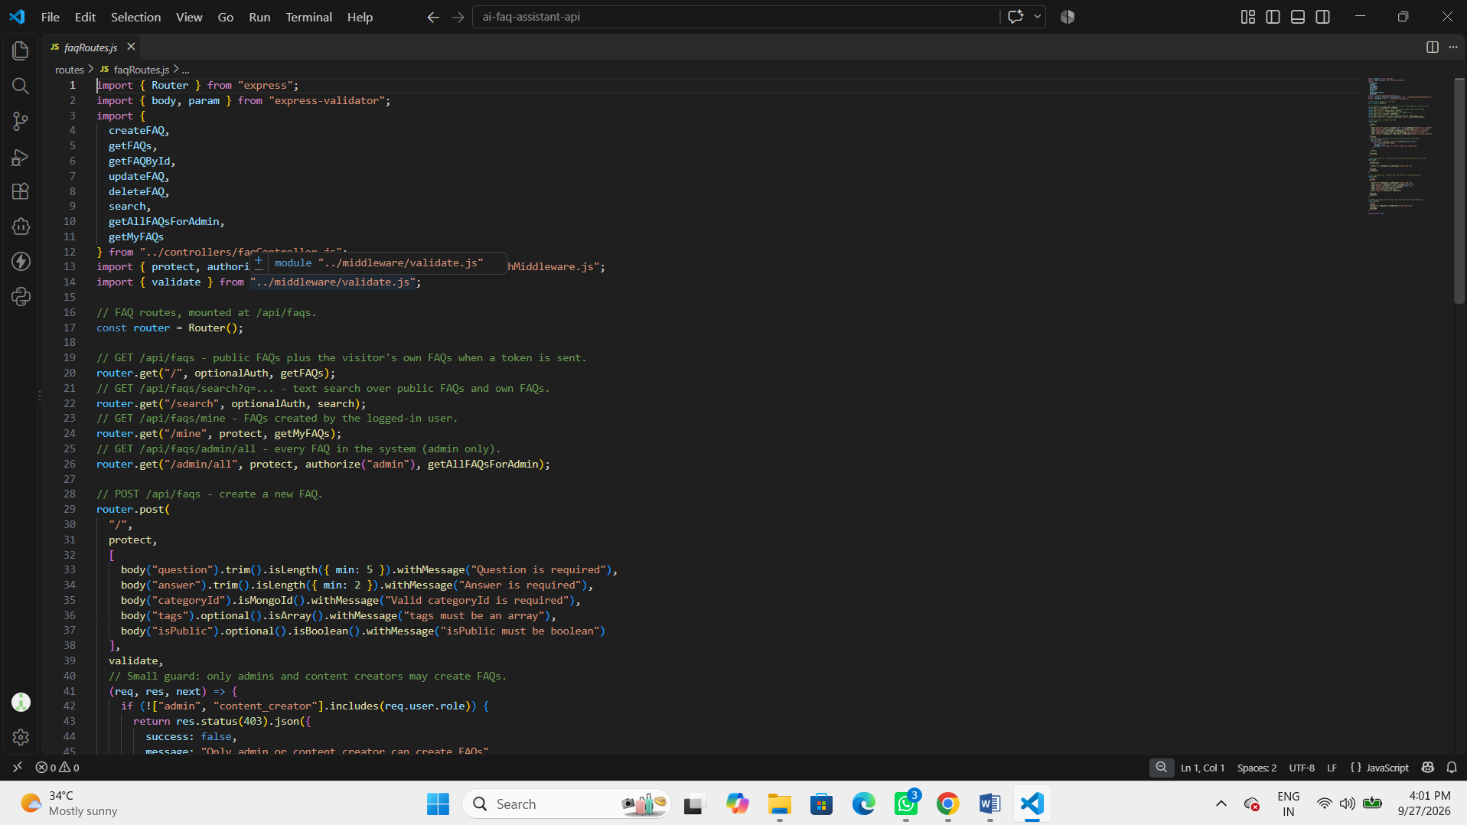
Figure 4: FAQ REST Route Definitions

7. CATEGORY DEVELOPMENT
The Category module was developed to organize FAQ content.

APIs
- POST /api/categories
- GET /api/categories
- PUT /api/categories/:id
- DELETE /api/categories/:id
Category creation, update, and deletion are protected for administrators, while category listing is publicly available.
Each FAQ stores a reference to its category through categoryId.

8. FEEDBACK DEVELOPMENT
The Answer Feedback module was developed to collect user feedback about FAQ answers.

APIs
- POST /api/feedback
- GET /api/feedback
Authenticated users can submit feedback using a FAQ reference, a helpful value, and an optional comment. Administrators can retrieve feedback records.

9. GOOGLE GEMINI AI DEVELOPMENT
Google Gemini was integrated as the AI service for the AI FAQ Assistant API.
The AI module provides:
- AI FAQ generation
- AI-assisted question answering
- Topic suggestions for generated FAQs
- Saving generated FAQ content into the FAQ collection

FAQ Generation API
POST /api/ai/generate-faq

Save Generated FAQ API
POST /api/ai/generated/:id/save

AI Answer API
POST /api/ai/answer
The Gemini service returns structured FAQ data for generation and text answers for question answering.
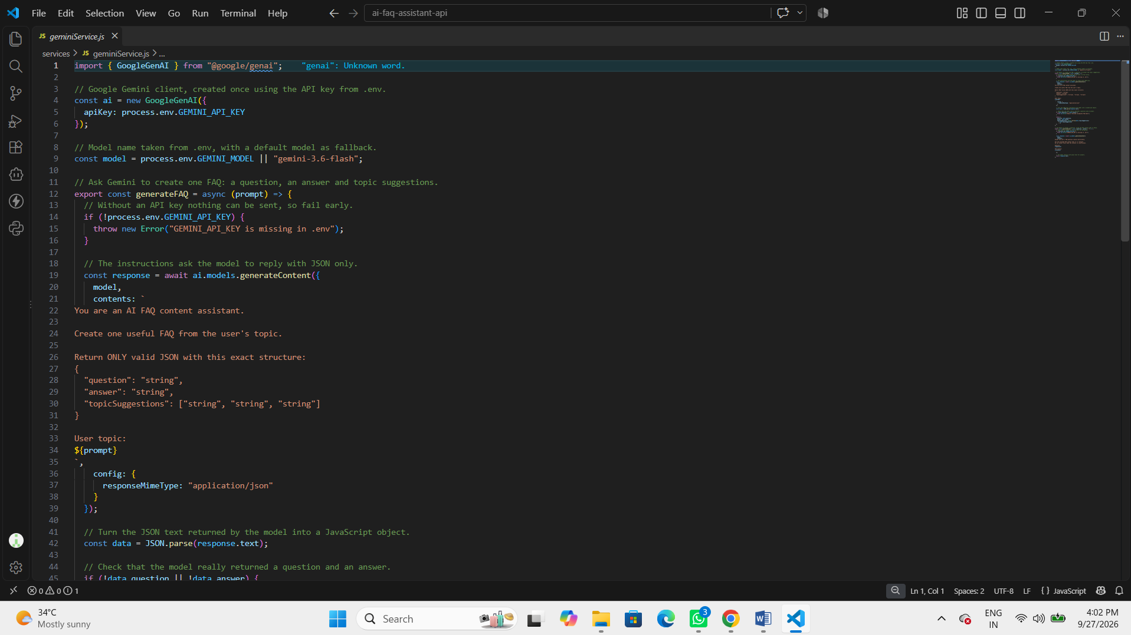
Figure 5: Google Gemini Service Implementation

10. PROMPT ENGINEERING DEVELOPMENT
Structured prompts were implemented inside the Gemini service for the two AI operations.
For FAQ generation, the prompt instructs Gemini to create one useful FAQ from the user's topic and return JSON containing a question, answer, and topic suggestions.
For AI question answering, the prompt provides the user's question and relevant FAQ context and requests a clear answer without inventing facts when the available context is insufficient.

Processing Flow
User Prompt
↓
Structured Gemini Prompt
↓
Google Gemini
↓
Generated FAQ JSON / AI Answer

11. MONGODB ATLAS SEARCH DEVELOPMENT
The project does not implement MongoDB Atlas Search. Instead, the FAQ model defines a MongoDB text index on question, answer, and tags, while the main FAQ search service performs keyword-based matching using regular expressions.

API
GET /api/faqs/search?q=<search-term>
The search service limits the number of query words, matches them against FAQ questions, answers, and tags, applies public/ownership visibility rules, and returns up to 20 results.
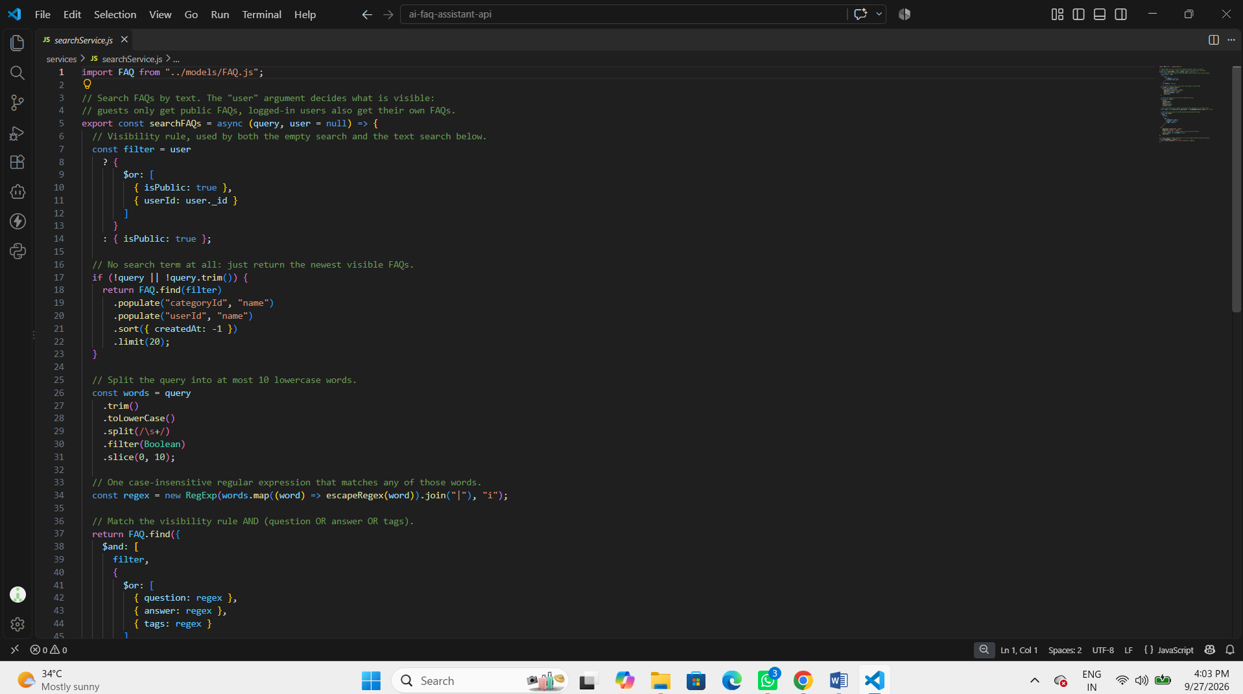
Figure 7: Keyword-Based FAQ Search Service

12. MONGODB ATLAS VECTOR SEARCH DEVELOPMENT
MongoDB Atlas Vector Search is not implemented in the uploaded project. There is no embedding service, vector index, or Atlas Vector Search implementation in the source files.
The current project uses MongoDB with Mongoose and keyword/text-based FAQ search. Therefore, no vector-search development evidence is included for this project.

13. SECURITY DEVELOPMENT
The backend security layer was implemented using:
- bcrypt password hashing
- JWT authentication
- Role-based authorization
- Request validation using express-validator
- FAQ ownership checks
- Rate limiting
- Helmet security headers
- CORS configuration
- Centralized error handling
- Sensitive configuration through environment variables
Sensitive values such as database connection strings, JWT secrets, administrator credentials, and Gemini API keys are stored outside the shared source files and are not included in this documentation.

15. API TESTING DURING DEVELOPMENT
The API is designed to be tested using Postman or Thunder Client. The project includes a Thunder Client testing guide covering public endpoints, authentication, role-based operations, FAQ CRUD, AI operations, feedback, and administrative operations.
Testing covered:
- Root and health endpoints
- User registration
- User login
- Authenticated profile access
- User management
- Category management
- FAQ creation, retrieval, update, and deletion
- FAQ keyword search
- AI FAQ generation
- Saving AI-generated FAQs
- AI-assisted question answering
- Answer feedback
- Admin-only operations
Postman / Thunder Client can be used for API-level testing.
For documentation screenshots, actual JWT tokens, passwords, API keys, and database credentials must be hidden or replaced with placeholders such as <JWT_TOKEN>.

16. TESTING RESULTS
The uploaded project contains a detailed Thunder Client testing guide with expected request methods, URLs, headers, request bodies, and response examples.
The source package does not contain a verified automated test report or a final numeric pass/fail result. Therefore, a specific overall testing score is not stated in this documentation.
The documented testing sequence covers the main API modules and expected error responses including validation errors, authentication errors, authorization errors, not-found errors, duplicate-value errors, rate-limit errors, and server/database errors.

17. MONGODB CONNECTION
MongoDB is connected through Mongoose in config/db.js. The connection uses the MONGO_URI environment variable. The application starts the Express server only after the database connection succeeds.
connectDB().then(() => {
app.listen(PORT, () => {
console.log(`Server running on http://localhost:${PORT}`);
});
});
The application reports a database connection message before starting the server. The actual MongoDB connection string is confidential and is not included in this document.

18. File Structure
The project is organized into configuration, controllers, middleware, models, routes, services, and application-level files.
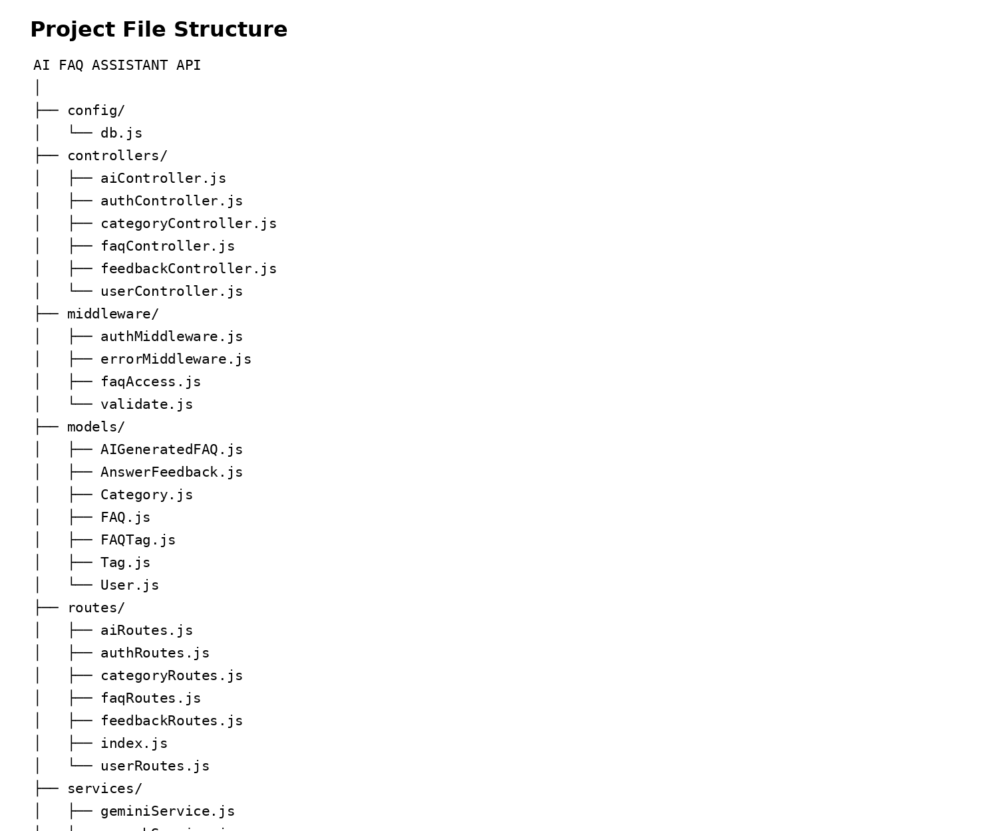
Figure 8: Complete AI FAQ Assistant API File Structure

19. DEVELOPMENT OUTCOME
The development phase resulted in a functional backend REST API containing:
- User registration and login
- JWT-based authentication
- Role-based authorization
- User management
- FAQ CRUD operations
- FAQ ownership and visibility protection
- Category management
- Tag and FAQTag relationships
- Keyword-based FAQ search
- Google Gemini AI integration
- AI-generated FAQ storage and saving
- AI-assisted question answering
- Answer feedback
- Mongoose schema validation
- Security middleware
- API testing support through Postman / Thunder Client
The Project Development Phase transformed the AI FAQ Assistant requirements into a functional backend REST API. The implementation follows a modular structure with separate controllers, services, routes, models, middleware, and database configuration. The system combines secure authentication, role-based access, FAQ management, keyword search, and Google Gemini AI capabilities.

Conclusion
The AI FAQ Assistant API provides a structured backend solution for managing frequently asked questions and AI-assisted support operations. The project uses Node.js, Express.js, MongoDB, Mongoose, JWT, bcryptjs, and Google Gemini. The implemented modules support authentication, role-based authorization, FAQ and category management, keyword search, AI-generated FAQ content, AI-assisted answers, and feedback. The development evidence included in this document is derived from the uploaded project source files, while confidential environment values are intentionally excluded.

